Part1 :
4 Types of Printmaking
Relief Print
http://www.youtube.com/watch?v=O0skLwaFpn0
Lithography
http://www.youtube.com/watch?v=JHw5_1Hopsc
Screen printing
http://www.youtube.com/watch?v=wogKeYH2wEE
Intaglio
http://www.youtube.com/watch?v=SNKn4PORGBI

Relief Printing Process  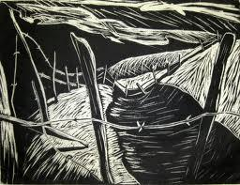 | Details of the Process:
Lithography Process  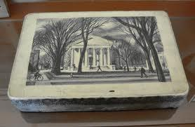 | Details of the Process:
Screen Printing Process  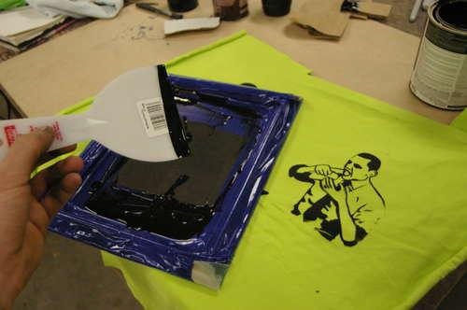 | Details of the Process:
Intaglio Process  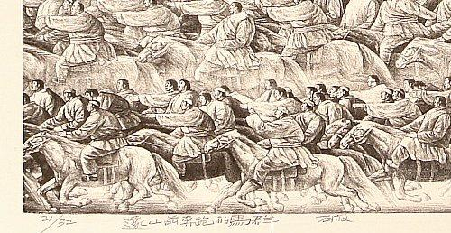 | Details of the Process:

Part2 :
Video Artist and Responses
After watching the videos for each artist write a reflective response to the artist and the work.

Eadweard Muybridge (1878) 4:04
https://www.youtube.com/watch?v=aG5erS2GNG0&t=119s

Georges Meilies (1902) 11:21/12:52
https://www.youtube.com/watch?v=RyGRpvA17wI
“A Trip to the Moon” with narration
https://www.youtube.com/watch?v=_pfdQ_ftHQs

Windsor McCay (1914) 6:28/5:50
“Gertie the Dinosaur”
Part 1 https://www.youtube.com/watch?v=mnuhP2URCoo
Part 2 https://www.youtube.com/watch?v=ixK1DffOsbE

Peter Campus (1973) 3:21
“Three Transitions”
https://www.youtube.com/watch?v=aVozAnBiZrg

Shirin Nashat (current) 8:37
https://www.youtube.com/watch?v=VXZkn0nL34Y

Reflective Responses:
Eadweard Muybridge (1878)

Georges Meilies (1902)

Windsor McCay (1914)

Peter Campus (1973)

Shirin Nashat (current)

